# Lab 4. Task 1- preparation task Template for answers

**Save this document as a .pdf document before submitting.**

*Student names and LiU-IDs: (Max 2 students per group):*

1. *Thomas Indrias (thoin216)*

*Submission date: 2018-12-14*

*Version (in case you need to re-submit): 1.0*

1. **Hough transform**

**1)** H1:

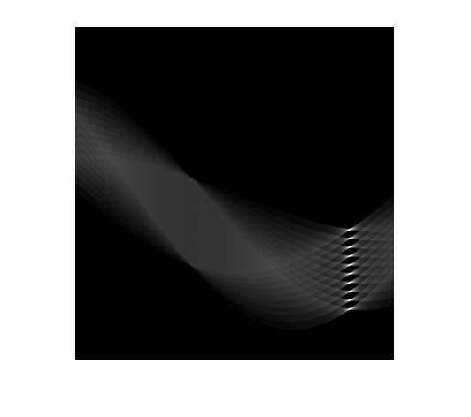

**2)** Your guess:

% 65 degreees (believe it or not). Through MATLAB data plot tool, I chose

% the pixel value for X axis (around 311). The ratio becomes 310/360 which

% I then multiplied with 180 degrees. Since angle is -90 to 90, I substract

% 90 degrees from the result. (310/360) * 180 - 90 = 65

**3)** What is the exact angle corresponding to the lines in $Image1a$?

% The exact value is 65 degrees.

**4)** What is the angle of **clockwise** rotation to rotate $Image1a$ to the horizontal level? Use your answer from problem 3.

% A rotation to the horizontal level would need an angle of 90 - 65 = 25

% degrees clockwise

**5)** Image1a_rotated:

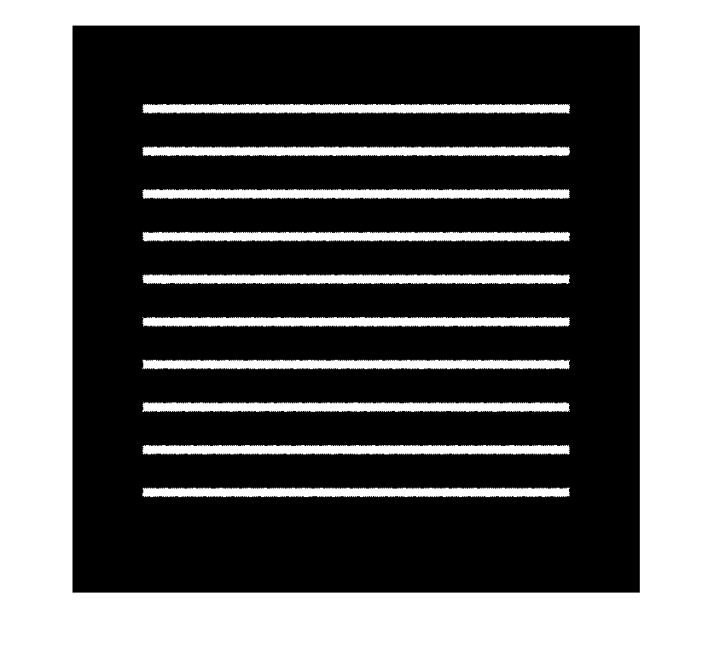

**6)** What is the exact angle corresponding to the straight lines in $Image1b$?

% Exact angle is -75 degrees.

**7)** What is the angle of **counterclockwise** rotation to rotate $Image1b$ to horizontal level? Use your answer from problem 6.

% 90 - 75 = 15 degrees counter clockwise.

**8)** Image1b_rotated:

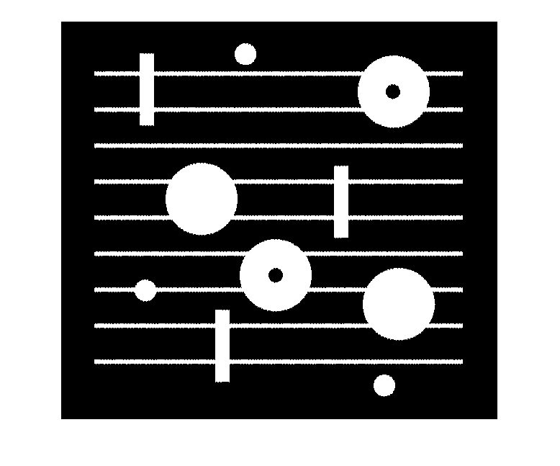

**9)** Image1c with noise removed:

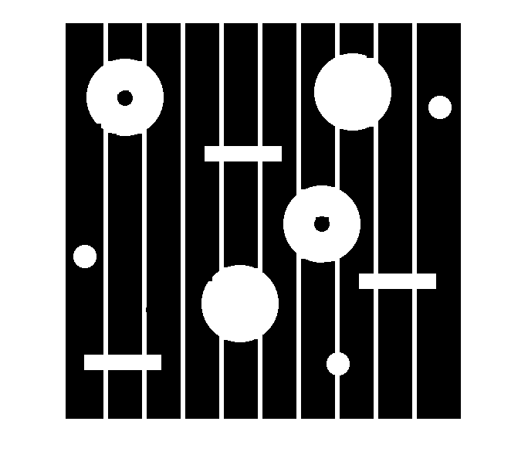

**10)** Image1c_clean (noise and lines removed):

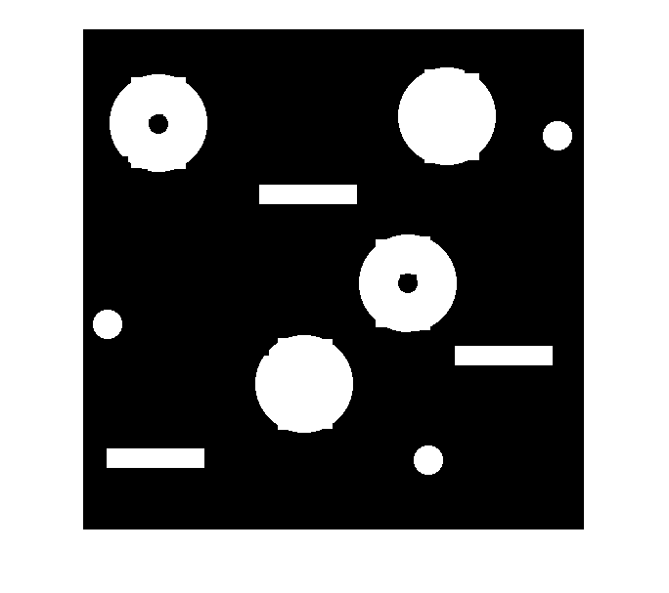

**11)** RGB-image displaying the 3 different classes of objects in different colors:

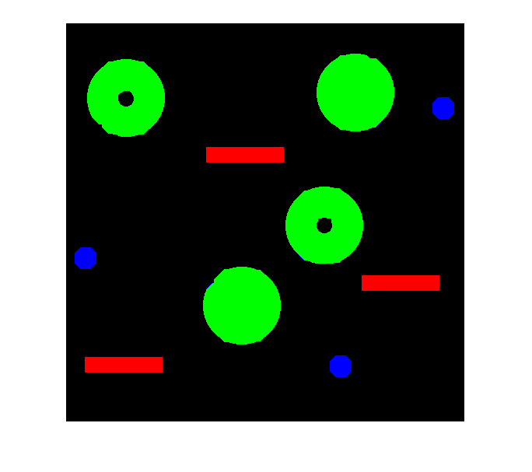

**12)** Labeled image, L, scaled by max value:

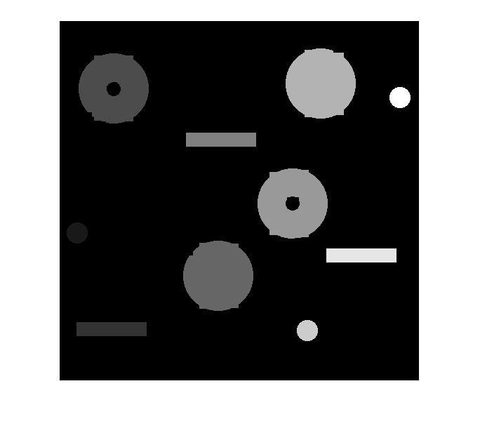

**13)** What are the perimeters for the large objects (having area > 3000 pixels)? %Perimeter(Large0) gives: 327.4740 325.6300 324.3400 324.9850

Image containing only the large objects:

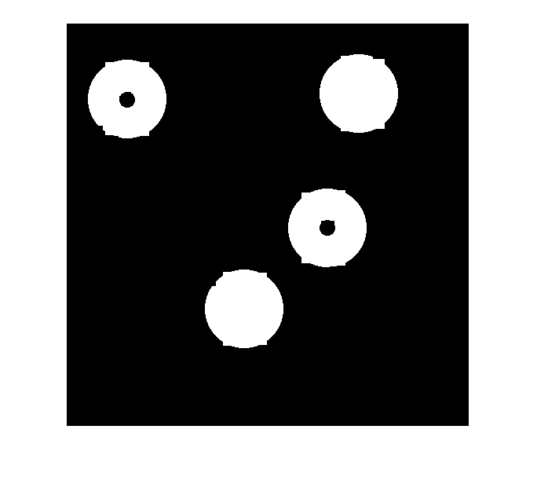

**14)** What is your selected threshold value?

What are the labels of the objects belonging to the class with the smallest perimeter?

% Threshold: 150

% Labels: 1, 8 and 10.

**15)** What are the labels of the objects belonging to the class with the largest perimeter, and that has no holes?

% Threshold: 250

% EulerNumber: 1

% Labels: 4 and 7.

Image containing only objects having the largest perimeter, without holes:

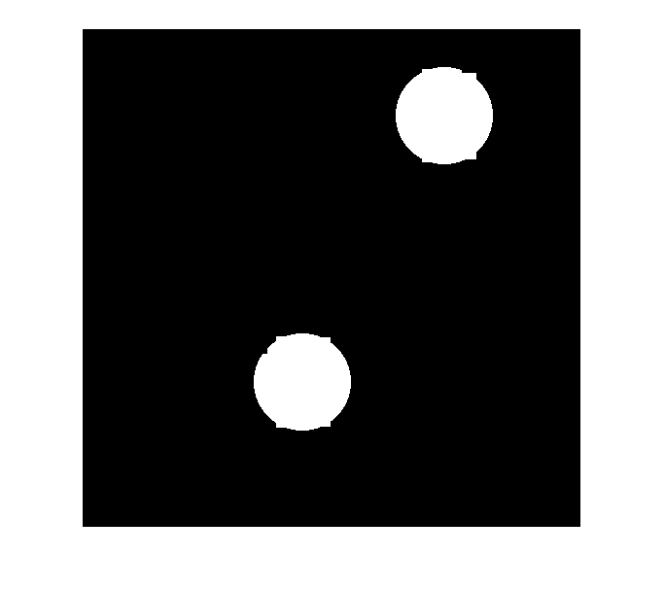

*Don’t forget to save the document as* ***.pdf*** *before submitting!*